**Task 2**

**Introduction -**

This document will demonstrate the improvement of Cloud Computing answers the usage of carrier company’s frameworks and open source gear. it'll also configure a Cloud Computing platform with a cloud provider company’s framework. it will also put into effect a Cloud platform the use of open source tools. This file will analyse the technical demanding situations for cloud packages and check their risks with the aid of analyse the most commonplace issues which arise in a Cloud Computing platform and talk suitable answers to these troubles and check the most common protection issues in cloud environments.

**Web Apps and Cloud Services**

**Upload either the HTML Website you have created in your HND/Y1 (Unit 10: Website) or any other website of your choice to one of the servers you have created above.**

**Test Website Hosting on Azure Server -**

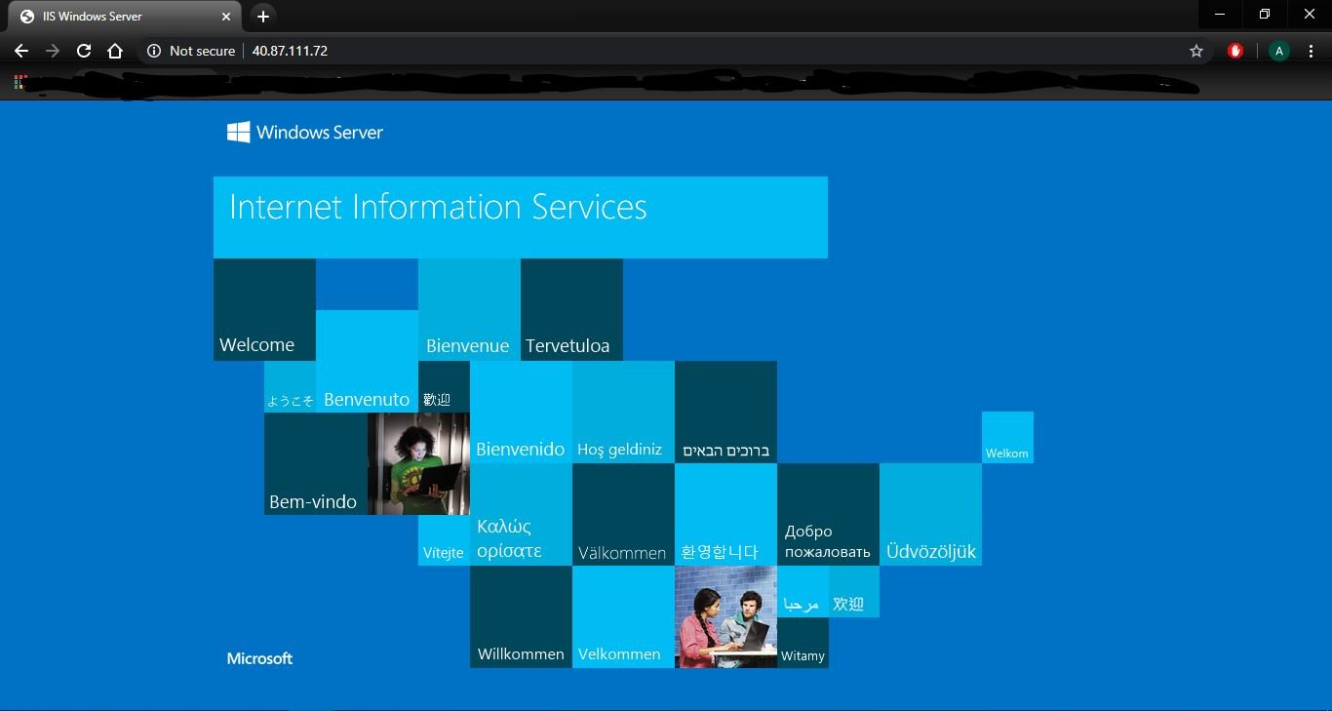

**My Website Hosting on Azure Server -**

**Home Page -**

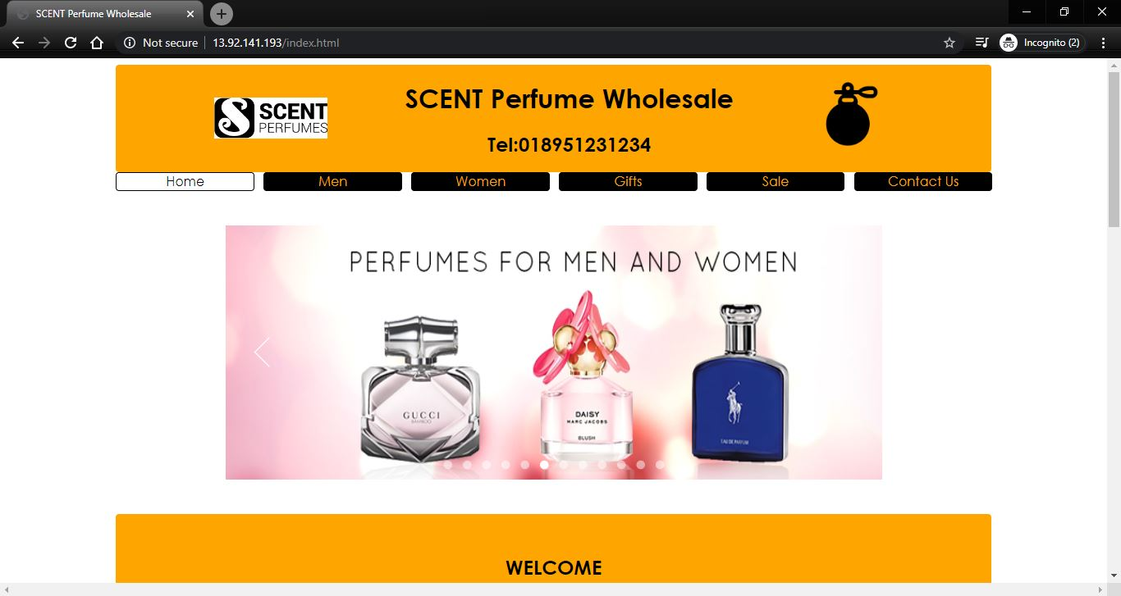

**Men’s Page -**

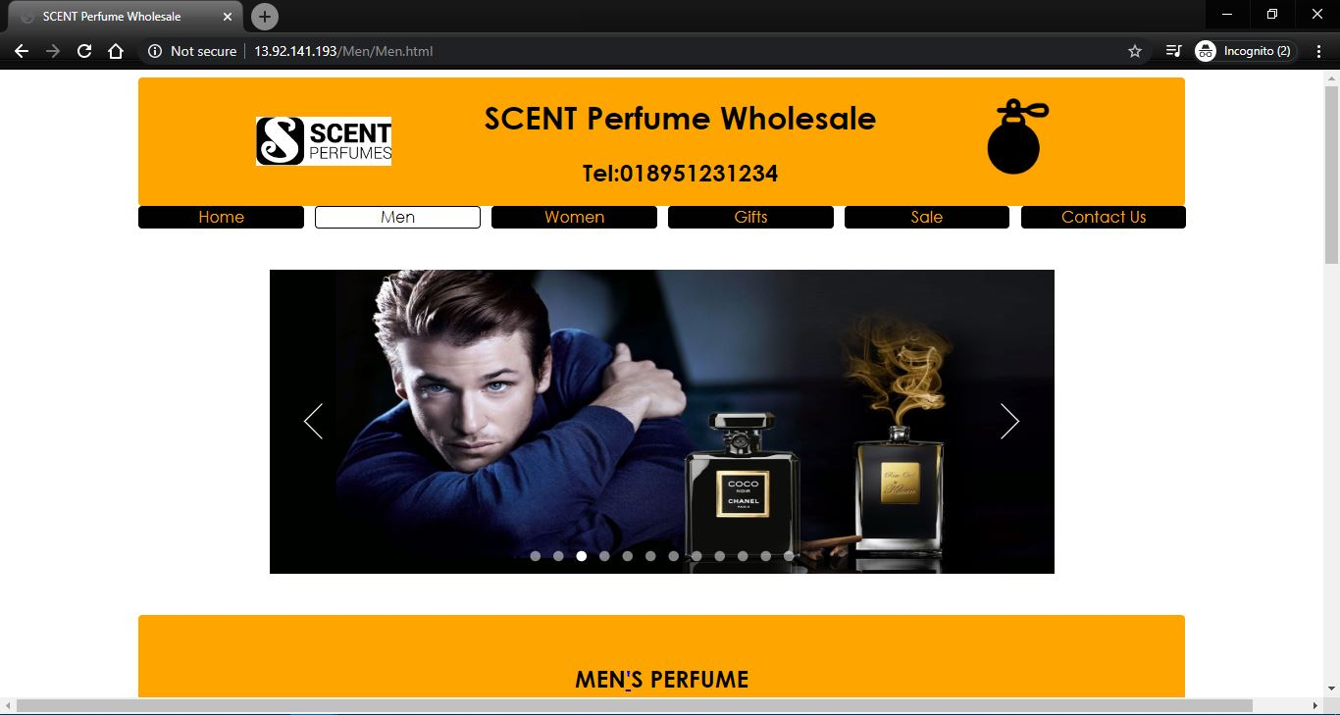

**Women’s Page -**

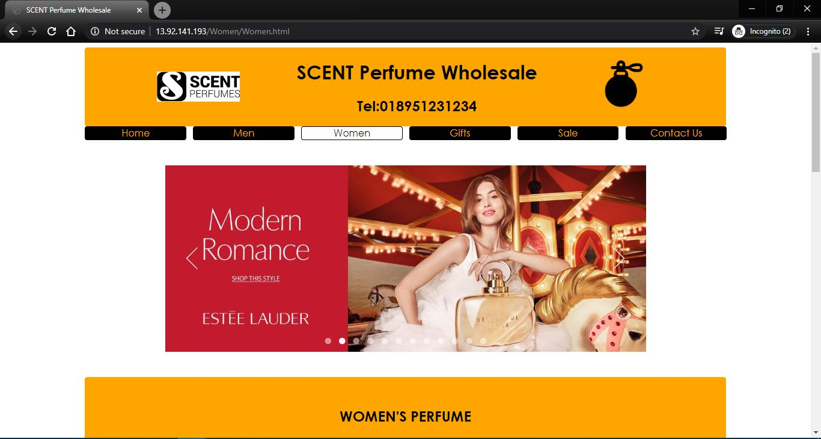

**Gift’s Page -**



**Sale’s Page -**



**Contact’s Page -**

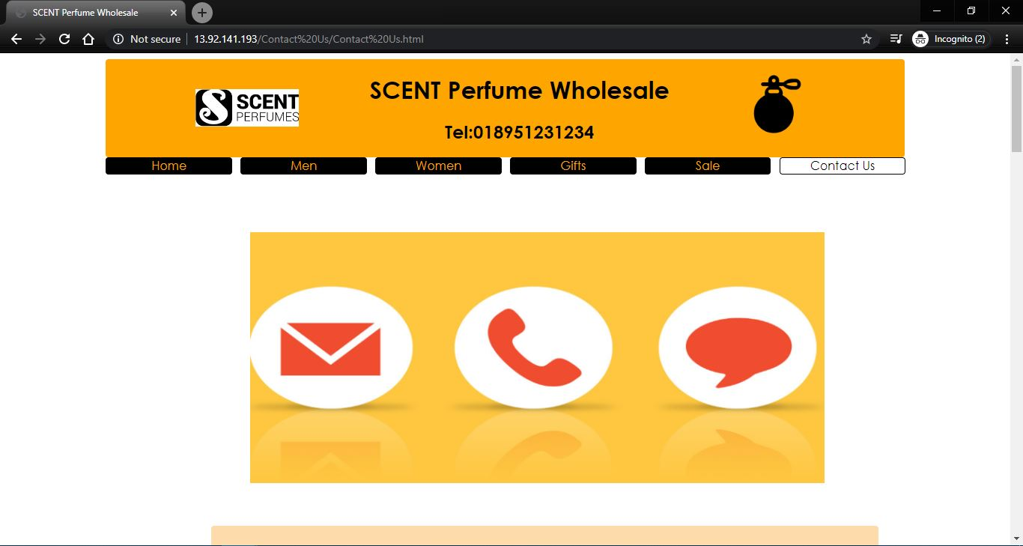

**Discuss the issues and constraints you will face during the deployment process.**

The issues and constraints that I have face during the development process are -

**1) Adding / Creating A Server -**

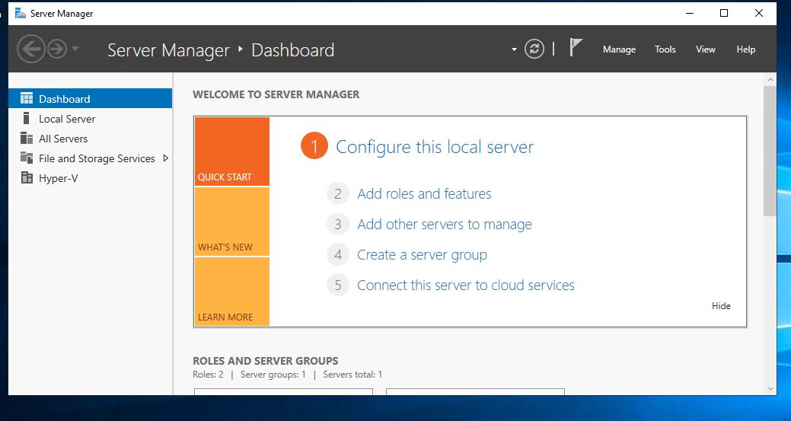

Creating a server was a bit of a challenge, as setting ports and IP addresses didn't seem to connect with the server. With a bit of trial and error it seems to work and connect with the server.

**2) Style (.css) not loading -**

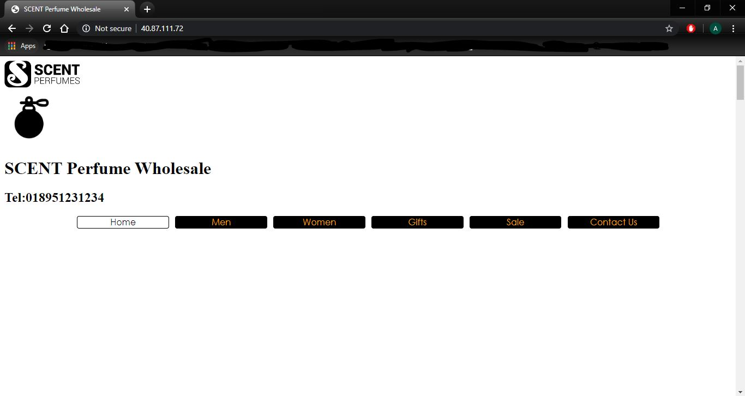

The design didn’t seem to load after uploading the website on to the server. Changing the features to the server didn’t seem to fix it as well. Finally I figured out that there was an error in linking the (.css) code with the (.html) code. Making those changes seemed to fix and load the design for the website.

**3) Slow Website Load times -**

When the website is online on the server, it takes a while to load but runs eventually. It may be because of the limitations on the server as the settings are set to default as requested by the assignment.

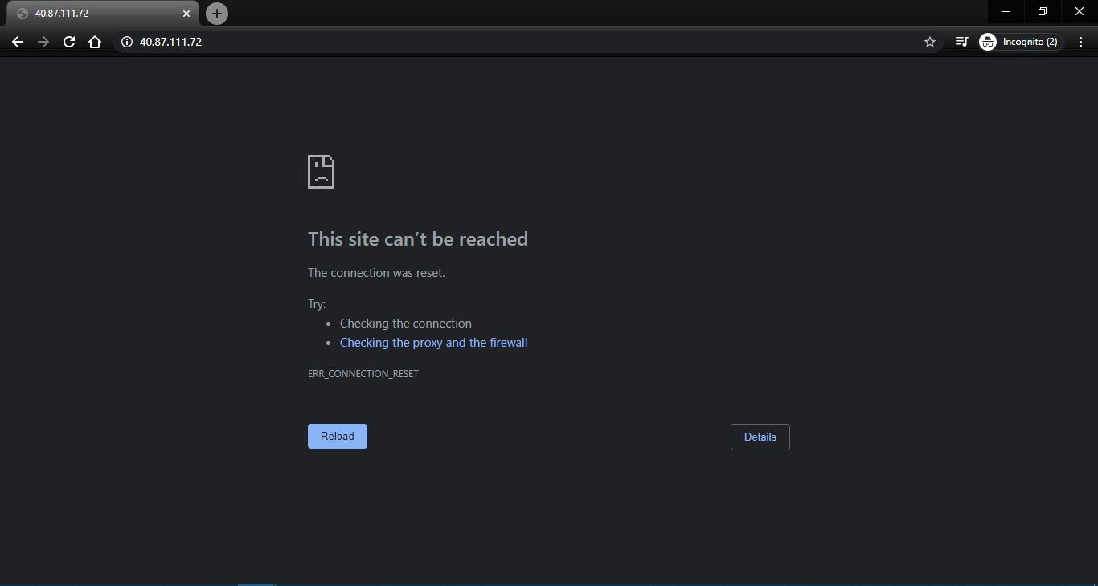

**Use the price calculator in Azure Portal to compare the monthly usage for at least 3 different VM sizes (either Windows or Linux based VMs) from 3 different regions and show if there are any savings that could be made and compare your findings with other cloud providers, e.g. AWS.**

**Azure Basic Monthly Usage of Vms for East US -**

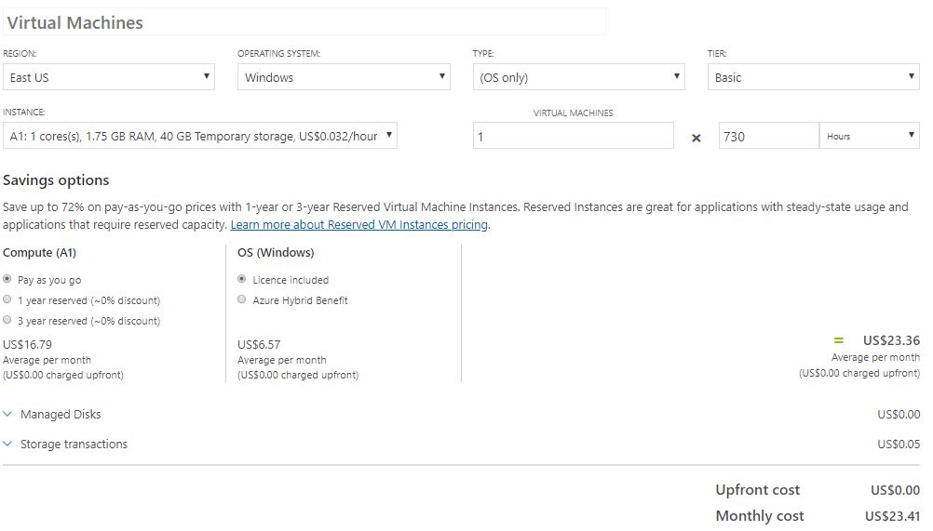

**Azure Low Priority Monthly Usage of Vms for East US -**

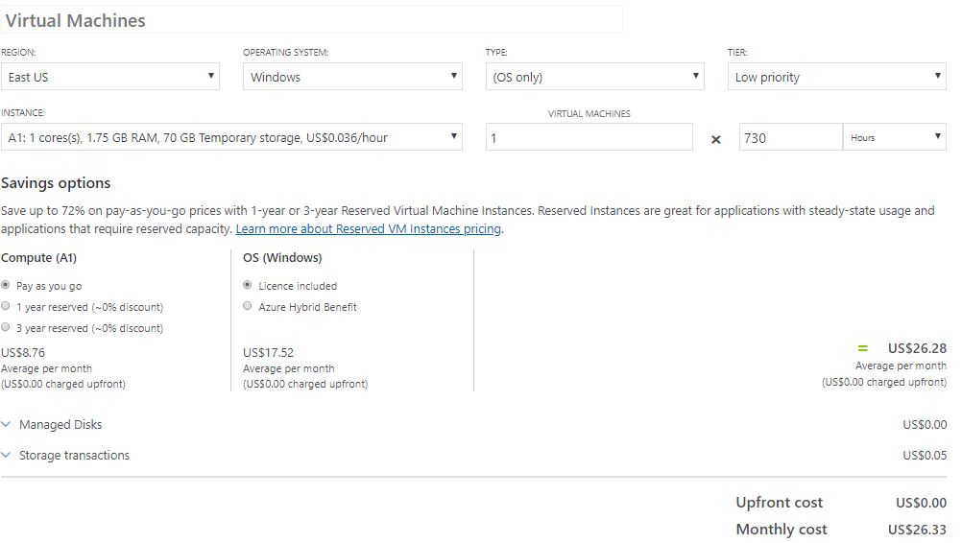

**Azure Standard Monthly Usage of Vms for East US -**

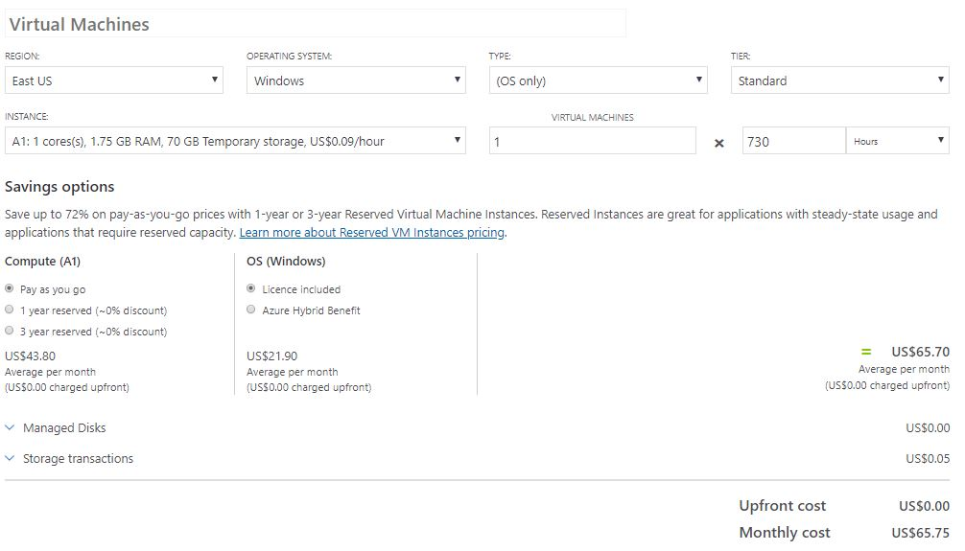

**Azure Basic Monthly Usage of Vms for West Europe -**

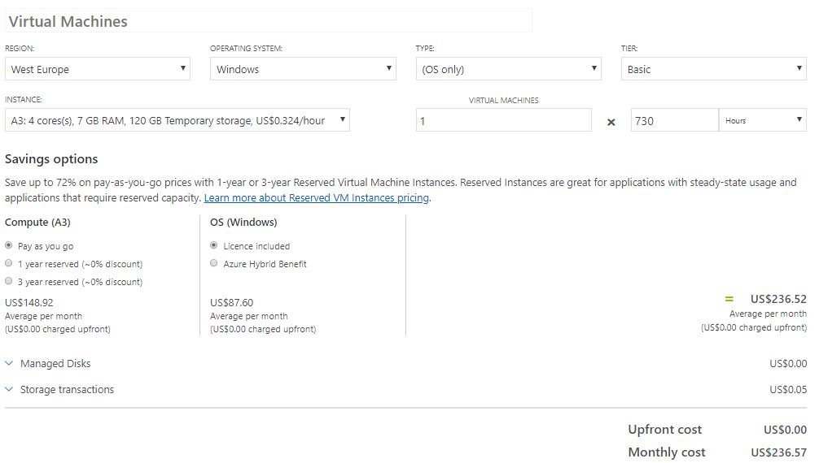

**Azure Low Priority Monthly Usage of Vms for West Europe -**

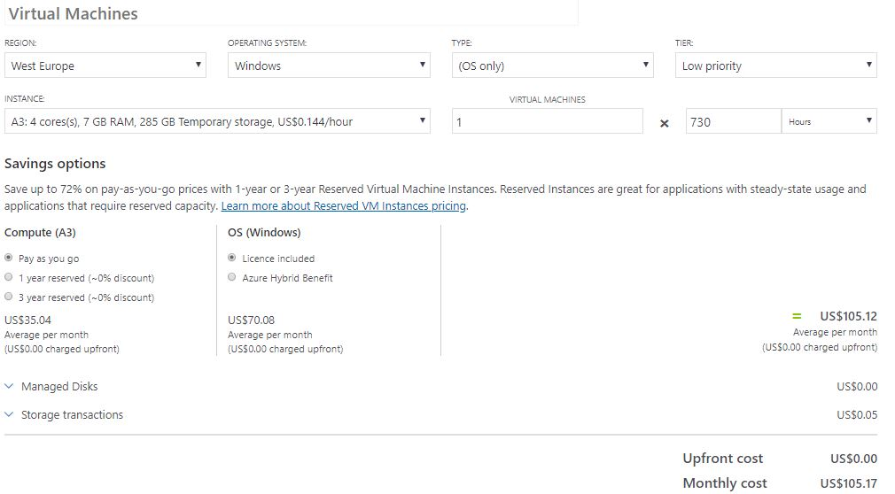

**Azure Standard Monthly Usage of Vms for West Europe -**

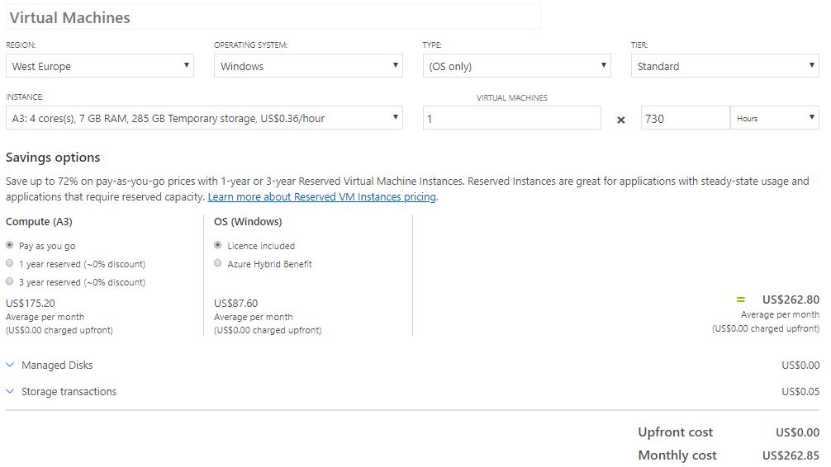

**Azure Basic Monthly Usage of Vms for UK West -**

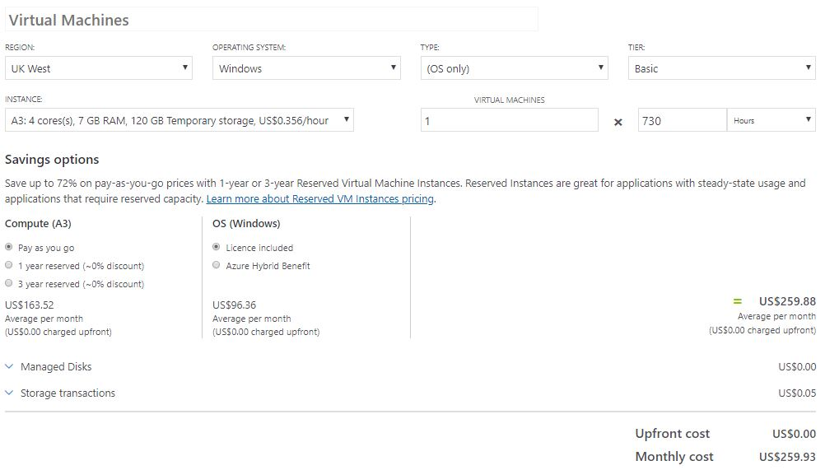

**Azure Low Priority Monthly Usage of Vms for UK West -**



**Azure Standard Monthly Usage of Vms for UK West -**

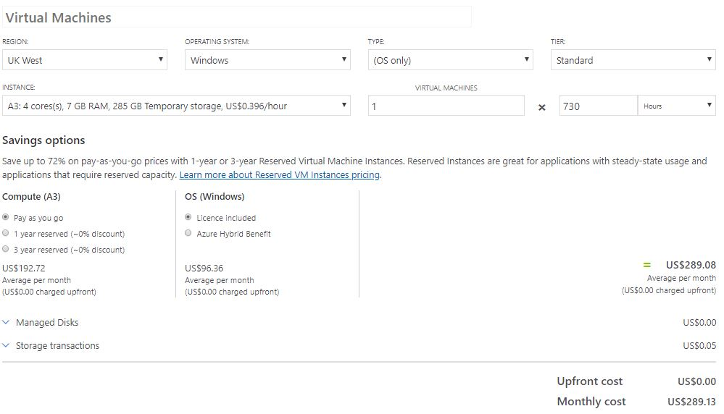

**AWS Standard Monthly Usage of Vms for East US (Ohio) -**

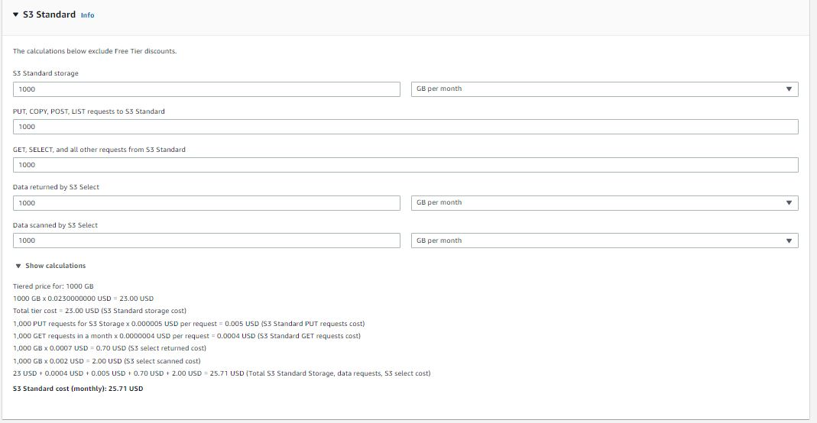

**AWS Standard Monthly Usage of Vms for EU (London) -**

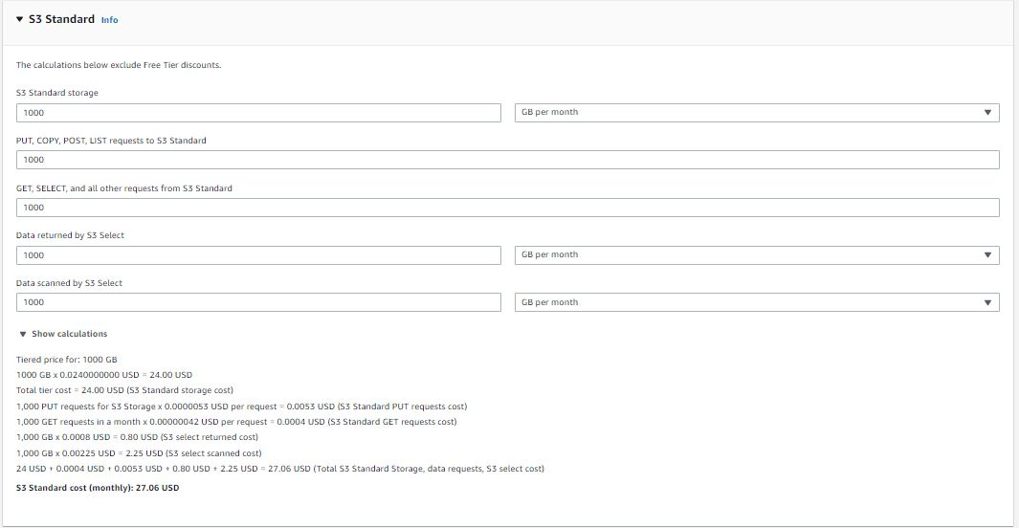

**AWS Standard Monthly Usage of Vms for EU (Ireland) -**

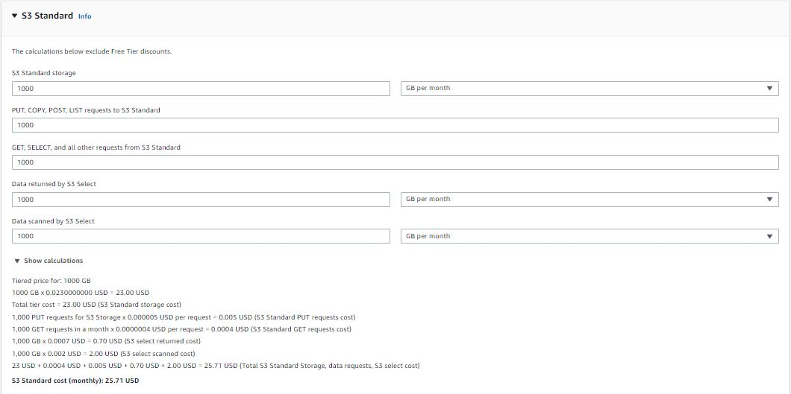

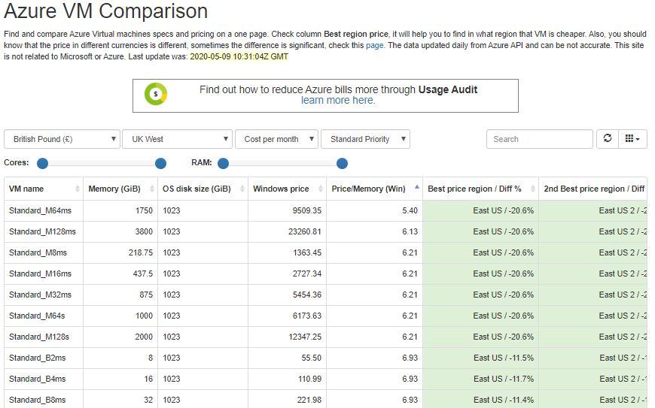

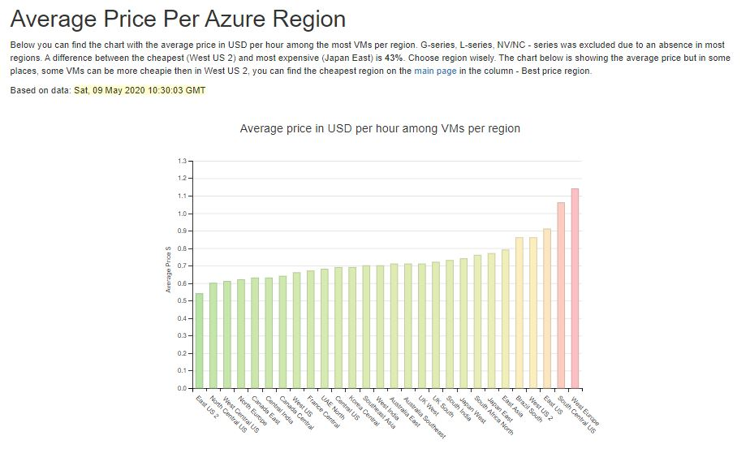

Here is a graph which represents all the regions average price in Dollars among VMs across the different regions.

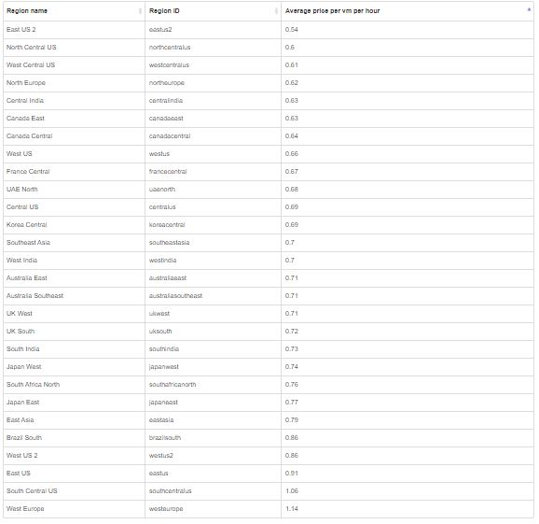

**Discuss how to overcome security issues associated with deploying your website in Azure.**

**Planning a recovery for disasters -**

It's now not feasible that disastrous facts misfortune or software mistakes credited to Azure will occur, besides it is crucial to have a complete lifestyle debacle healing plan installation. Sky blue itself can be utilized to reestablish misfortunes each time carried out as a reinforcement solution for network stockpiling. ensure to ponder the kinds of fiasco conditions which might be honestly one in every of a type to cloud facilitating on stages like Azure and plan as desires be.

**Compatibility with Applications -**

Aside from ensuring that databases stay best whilst going for walks on Azure, it's miles furthermore critical to assure that applications are precise before taking a jump to the cloud. The manner into this is making an attempt. located the software into an Azure test state of affairs and in a while started out the trying out method. It is sizable that this be exhaustive, thinking about locating actual similarity issues within the wake of going to advent is unstable to amend without sizable assistance disturbances.

**Application Management and Monitoring -**

Any area your applications are facilitated, you need to have an appropriate strategies installation so that you can address the ones applications viably. Earlier than you bring to a creation area in the cloud you need to assure that you recognize what management degree understanding you want and what your capability arranging technique is. In which will the information for software watching pass? fortunately the Azure SDK accompanies an indicative API that may find troubles with event logs, crash dumps and follow disappointments. by using the API, it's far conceivable to set up checking alternatives in an effort to make gazing and arranging typically easy.

**Issues with security -**

One of the primary problems of CIOs at the same time as considering transferring basis and programming out of doors to a cloud stage is statistics safety. utilising comfy conventions on the utility stage is enough depending upon the particular use case, however creation and usage of a virtual 255fb4167996c4956836e74441cbd507 device with begin to finish encryption is in reality a solution that everybody wishes to recollect.

**Transfer and Conversions for Virtual Machines -**

The appropriation of VMs with the resource of the ventures has been bewildering consequently nearly absolutely, any IaaS movement will incorporate various gift virtual machines. whilst Azure is a super VM facilitating choice and has tremendous similarity with VMs from home windows Server 2008 R2 and lots of Linux VMs, it's miles a sensible plan to test similarity for every VM implied for relocation.

**Database migration common problems -**

Numerous project applications depend on outer databases in order to complete their capacities. Even as it's miles plausible to relocate applications to Azure whilst facilitating the database in-residence, shifting the database itself to Azure is a suitable idea and has several blessings. In any case, it is vital to distinguish and foresee similarity issues amongst Azure stockpiling and the modern-day application stockpiling. opposite functions with reinforced orders or variable types is viable wherein the source database have become made with now obsolete renditions of database programming. converting over the database without misplaced loyalty or capability frequently expects modifications to applications and the administrations of database professionals previous moving to Azure.

**Existing Dependencies -**

Programs these days most effective now and again paintings in a vacuum. Even as moving any software program to the cloud, situations have to be considered. There are distinct affiliation setups that might be negated via the float as a result the ones should be resolved earlier than venturing out to save you right help interferences.

**Downtime System Challenges -**

When creating a vast motion 255fb4167996c4956836e74441cbd507 time is inescapable. Wiping out all personal time is a dream, so it's far smarter to well know that there may be a holiday and plan for it in a like manner. carefully gauge how a lot tour each progression of motion will motive and try to spread it out and plan it to have negligible impact.

**Conclusion -**

This report demonstrates the development of Cloud Computing answers the use of carrier provider’s frameworks and open source equipment. It additionally configures a Cloud Computing platform with a cloud service company’s framework. It additionally Implements a Cloud platform using open source gear. This file will analyse the technical demanding situations for cloud applications and verify their dangers by analyse the maximum common troubles which stand up in a Cloud Computing platform and talk suitable solutions to those issues and assess the most not unusual safety issues in cloud environments.

**Resources -**

Saviantconsulting.com. 2020. *10 Azure Migration Challenges & How To Overcome Them*. [online] Available at: <https://www.saviantconsulting.com/blog/overcoming-10-azure-migration-challenges.aspx> [Accessed 9 May 2020].

Pietschmann, C. and Pietschmann, C., 2020. *How To Compare Azure VM Pricing Across Azure Regions | Build 5nines*. [online] Build 5Nines. Available at: <https://build5nines.com/how-to-compare-azure-vm-pricing-across-azure-regions/> [Accessed 9 May 2020].